Lab: Infrastructure as Code
Lab for the "Containers and Clouds" course @ SoftUni

NGINX Docker Container
It is time to create our first infrastructure. We will provision an NGINX Docker container using Terraform.
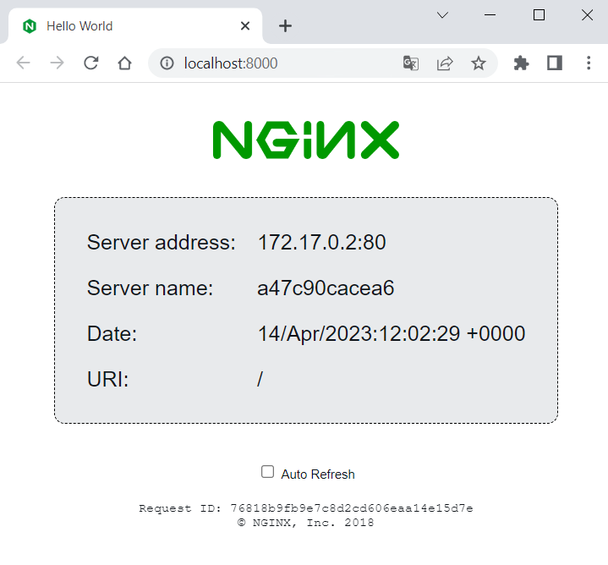
For this, you should have Docker running.

Step 1: Write the Configuration
First, create a directory that will keep your Terraform configuration files. Do it in a way you like – using File Explorer or a terminal. Then, create a file with the .tf extension in the folder, where we will define the infrastructure that we want:
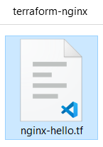
Open the file in an editor of your choice and let's write the configuration for the NGINX container.
Start by adding a terraform {} block, which contains Terraform settings, including the required providers Terraform will use to provision your infrastructure.
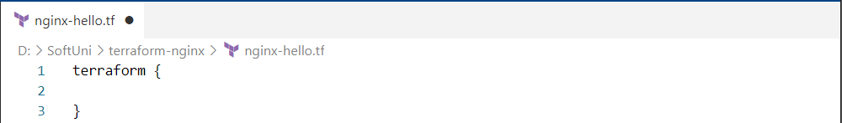
Each Terraform module must declare which providers it requires, so that Terraform can install and use them. Provider requirements are declared in a required_providers {} block in the terraform one and consist of a local name, a source location, and a version constraint.
In our case, we need Docker, so we should install a provider for it. Providers are installed from the Terraform Registry by default and the one we need is called "kreuzwerker/docker". (https://registry.terraform.io/providers/kreuzwerker/docker/latest). Use it like this:
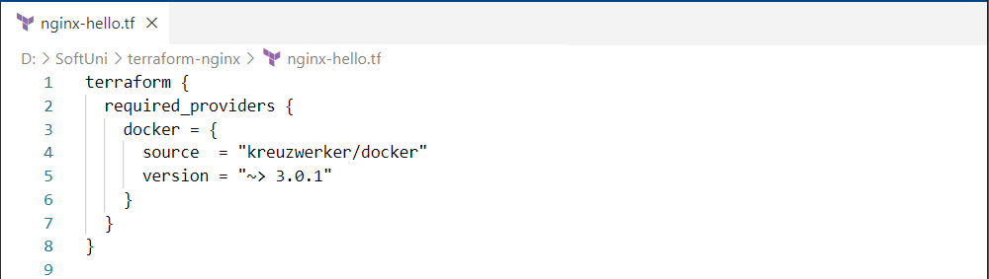
Provider's local name is its unique identifier within this module (in our case "docker"), the source defines the global source address for the provider you intend to use and the version constraint specifies which subset of available provider versions the module is compatible with.
Next, the provider {} block configures the specified provider, in this case "docker". Configure Docker to connect to Docker daemon and interact with Docker containers and images on a Windows host using a named pipe: "npipe:////./pipe/docker_engine":
Now we need to pull the "nginxdemos/hello" image from Docker Hub to later create a container with it. To do this, you need to create a Terraform resource.
Resource blocks are used to define components of your infrastructure. They have two strings before the block: the resource type and the resource name. Together, the resource type and resource name form a unique ID for the resource.
Use the "docker_image" Terraform resource and "nginx" for a resource name. Also, provide the name of the Docker Hub image you want to use:
At last, create a resource for the Docker container, using the image we defined as a resource (with its unique resource ID as image name). Also, you should give a name to the container and map ports:
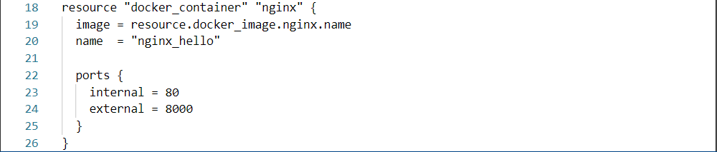
As you can see, the resource blocks can also contain arguments which you use to configure the resource.
Now your Terraform configuration is ready. Save the file and see how to use it in the next steps.

Step 2: Initialize the Directory
When you have a configuration, you need to initialize a configuration directory, which downloads and installs the providers defined in the configuration. Do it with the terraform init command in the Terraform configuration directory:
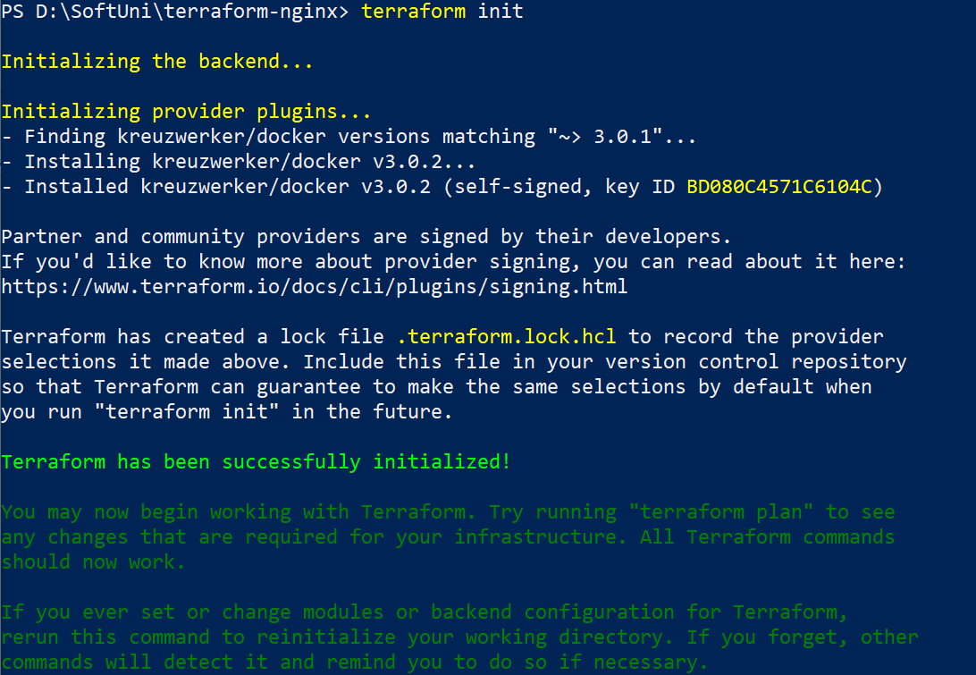

Terraform downloads the docker provider and installs it in a hidden subdirectory of your current working directory, named .terraform. It also creates a lock file named .terraform.lock.hcl which specifies the exact provider versions used, so that you can control when you want to update the providers used for your project:
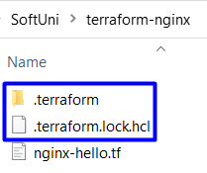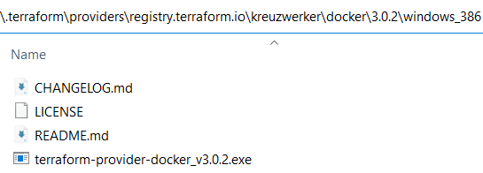
Then, before we create the container, let’s format and validate the configuration we have written.

Step 3: Format and Validate the Configuration
The terraform fmt command automatically updates configurations in the current directory for readability and consistency:
Terraform will print out the names of the files it modified, if any. In our case, our configuration was formatted well.
You can also make sure your configuration is syntactically valid and internally consistent by using the terraform validate command:
Validation was successful and our configuration is valid. Now it is time to apply it.

Step 4: Create Infrastructure
Use the terraform apply command to execute the configuration file and apply it to create the wanted infrastructure. Terraform will print a similar output:
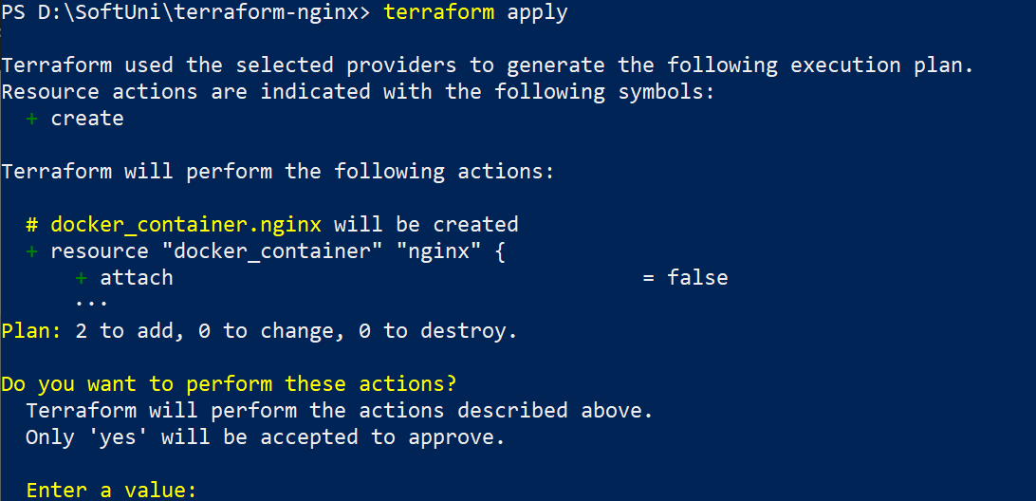

Before it applies any changes, Terraform prints out the execution plan which describes the actions Terraform will take in order to change your infrastructure to match the configuration. Terraform will now pause and wait for your approval before proceeding.
In this case the plan is acceptable, so type "yes" at the confirmation prompt to proceed:
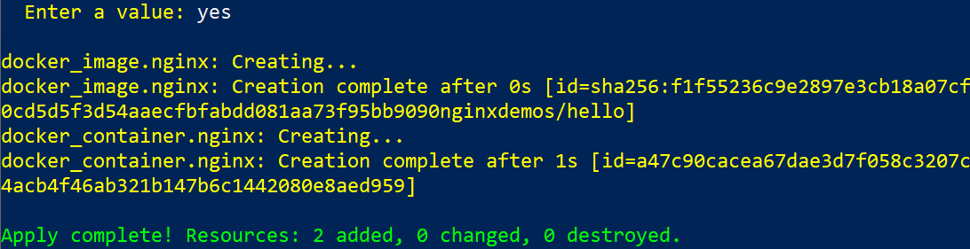
Terraform has created the infrastructure you want, which includes 2 resources – the container image and the container itself. You can look at them in Docker Desktop:
You can also visit http://localhost:8080/ to validate that the NGINX container is started and working:

You can also inspect the state of the resources that Terraform manages, as it wrote data into the terraform.tfstate state file when you applied your configuration:
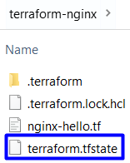
Inspect the current state using the terraform show command:
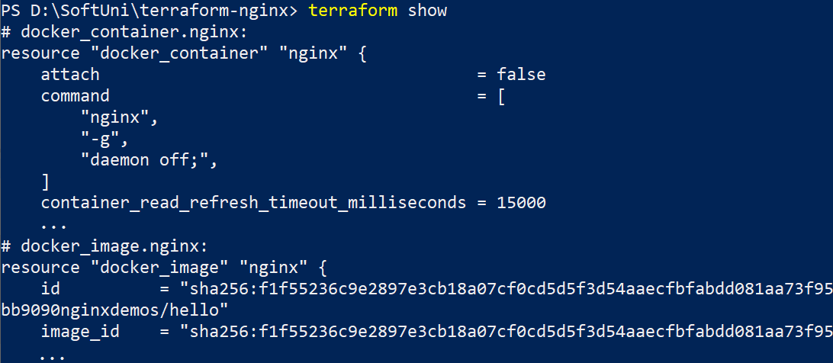
You have your Terraform configuration and resources. Now let's see how to modify them.

Step 5: Update Configuration
To change your configuration, make changes to the .tf configuration file. For the example, let's change the external port of the container from 8000 to 5000:
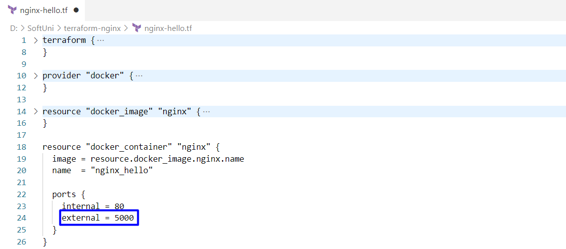
Save the file and apply the changed configuration:
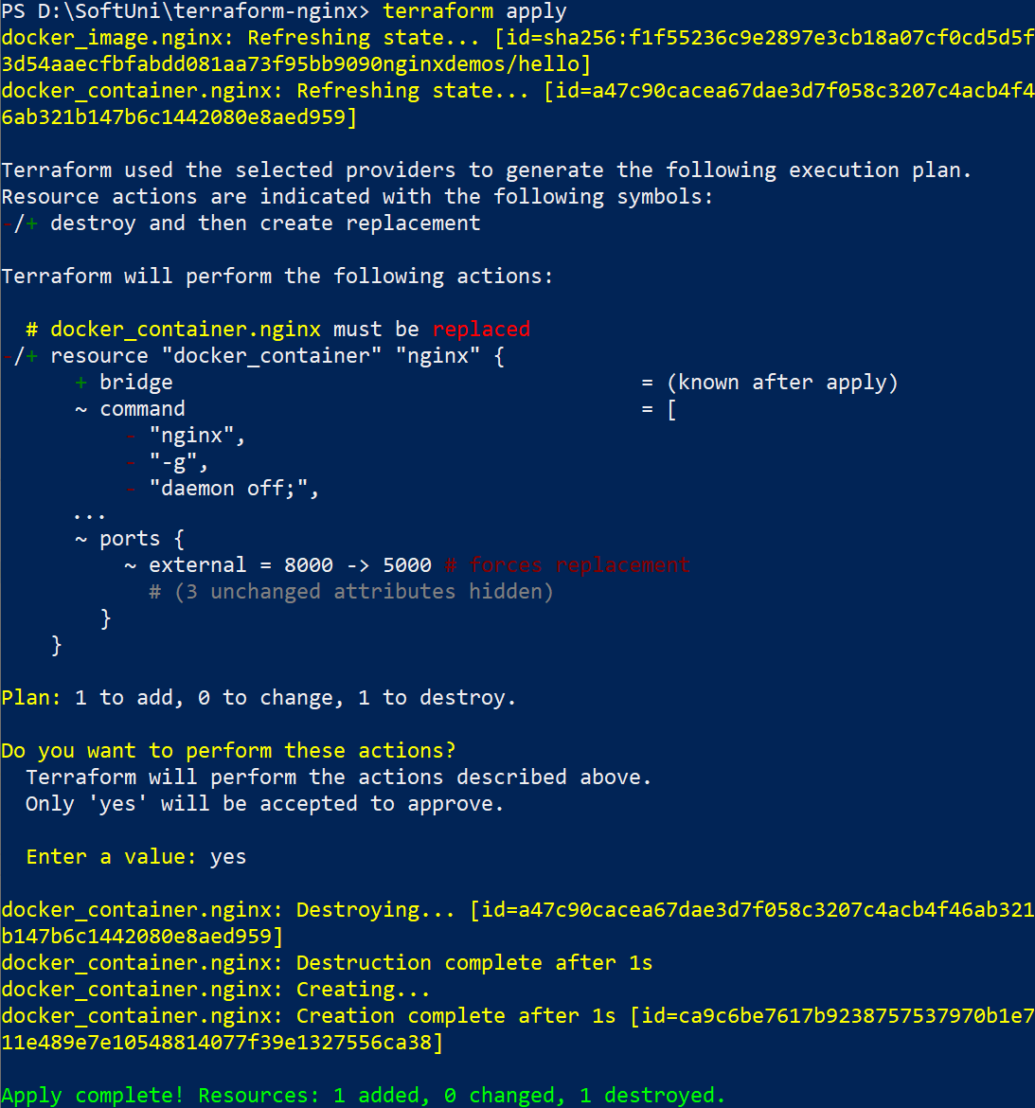
The Docker provider knows that it cannot change the port of a container after it has been created, so Terraform destroys the old container and creates a new one.
And you have your new container, accessible on http://localhost:5000/:
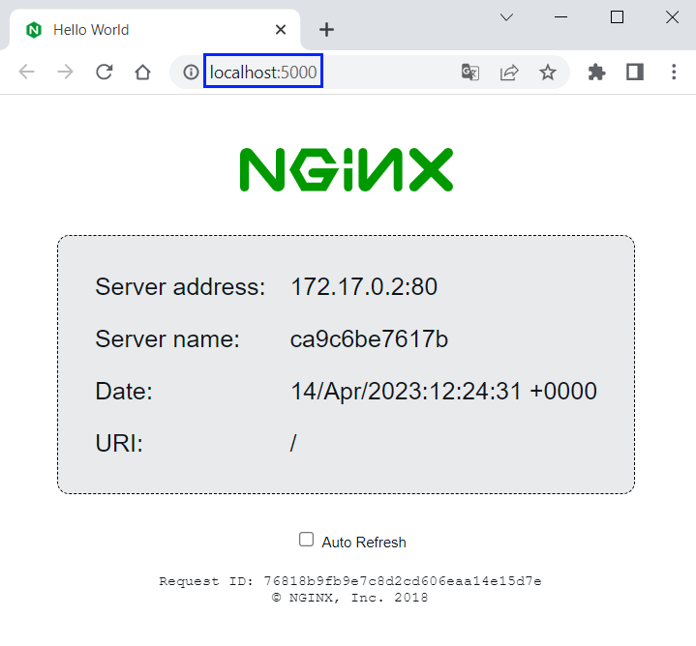
As you saw, you can change the Terraform configuration and resources easily in a way you want. However, don't forget to examine Terraform execution plans carefully before applying them, so that you don't perform incorrect or dangerous actions.

Step 6: Destroy Configuration
Once you no longer need infrastructure, you may want to destroy it. Use the terraform destroy command to terminate resources managed by your Terraform project.
Destroy the resources you created:
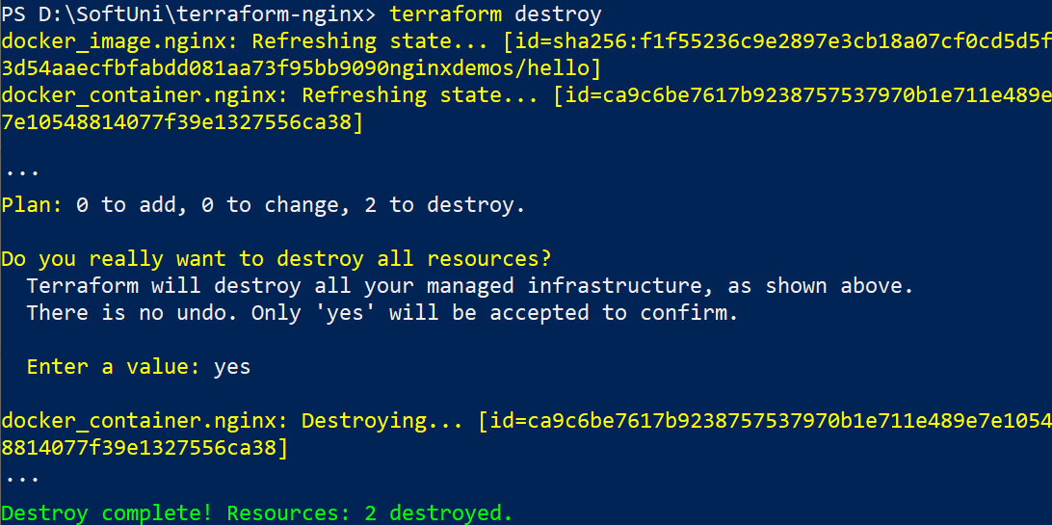
Terraform destroys resources in a suitable order to respect dependencies. You can verify that the NGINX image and container don't exist anymore in Docker Desktop.

